Alg 3 Summer Name: ____________________________

______________ _____________

WS Assessment

Target 5:

Inverse functions

**I can:**

* Use symmetry property to create inverse
* Find inverse function of linear, quadratic, radical and fractional functions with graphs
* **Unit 2: Function and Their Inverse**
* **CCSS.Math.Content.HSF.BF.B.4**: Find inverse functions
* **CCSS.Math.Content.HSF.BF.B.4.A**: Solve an equation of the form f(x) = C for a simple function f that has an inverse and write an expression for the inverse.

 For example, f(x) =2 x3 or f(x) = (x+1)/(x-1) for x ≠ 1

* **CCSS.Math.Content.HSF.IF.B.5**: Relate the domain of a function to its graph and, where applicable, to the quantitative relationship it describes. For example, if the function h(n) gives the number of person-hours it takes to assemble n engines in a factory, then the positive integers would be an appropriate domain for the function.*
* **CCSS.Math.Content.HSF.BF.A.1**: Write a function that describes a relationship between two quantities
* [**CCSS.MATH.CONTENT.HSF.IF.C.7.B**](http://www.corestandards.org/Math/Content/HSF/IF/C/7/b/)**:** Graph square root, cube root, and piecewise-defined functions, including step functions and absolute value functions

Inverse Functions**:***Only* ***one on one*** *function has inverse- horizontal line test*

Draw the inverse of each graph and show the symmetry line

|  |  |
| --- | --- |
|  |  |
|  |  |

The inverse function is denoted as f -1(x). Find the inverse of f(x), given:

f(x) ={(2, 7), (4, 9), (10, 16), (22, 62) (-3, 9)}

f -1(x) = {? Step 1 Solve for x

Find an inverse of each following equations: Step 2 Switch x and y, then rewrite y as f-1(x)

y = 5x y = 2x – 4 $y=\frac{-2}{3}x+6$

Note: the denote of f(x) or y are interchangeable

Find the inverse for the following (you want to rewrite as y = first)

$f\left(x\right)=6x+3$ $f\left(x\right)=\frac{1}{3}x-6$ $f\left(x\right)=2(x-3)$

Find the inverse for the following:

y = x3 – 5 y = 2(x+6)3

Find the inverse of $y=\sqrt{4x-16}$.

Graph both the original and inverse here and show me for stamp

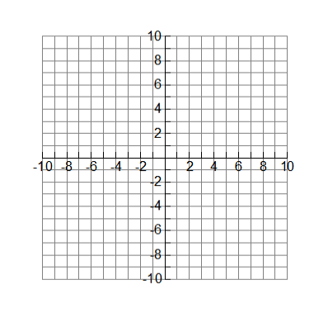

Find the inverse of $y={(x+2)}^{2}-3$. Show me for stamp

Find the inverse of quadratics function. You want to convert to vertex form first

y = x2 + 2x + 5 (right branch) y = x2 – 4x – 5 (left branch)

y = 4x2 + 6x – 2 (right branch) y = 4x2 – 8x + 10 (left branch)

Show me the original and inverse of the following for stamp

y = 2x2 – 5x + 10 y = 3x2 – 6x + 5

(right branch) (left branch)

Write the piecewise function for the following and its inverse. Show me for stamp

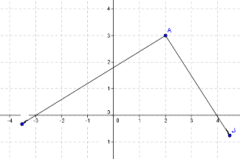

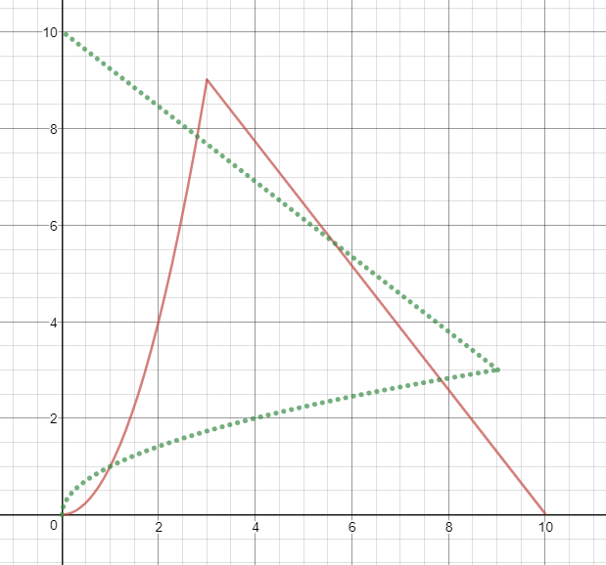

Find the inverse of fractional function

$y=\frac{1}{x}$ $y=\frac{1}{x+1}$ $y=\frac{1}{2x+1}$

$y=\frac{x}{x+1}$ $y=\frac{x}{x-1}$

$y=\frac{x+4}{3x+5}$ $y=\frac{x-4}{3x-5}$

Find the inverse and show me graph of both for stamp $y=\frac{x+3}{2x-7}$

If *p* and *q* vary inversely and *p* is 8 when *q* is 29, determine *q* when *p* is equal to 116

Hint: p1q1 = p2q2

When building a house, the number of days required to build is inversely proportional to with the number of workers. One house was built in 31 days by 32 workers. How many days would it take to build a similar house with 8 workers?

When renting a limo for prom, the number of people is inversely proportional to the cost per person. Originally there were 12 people and the cost per person was $20. If the number of people changed to 3, what would be the new cost per person?

**Assessment Target 5**

**I can…** find inverse of linear, quadratic, radical and fractional function

1. Find the inverse of linear function f(x) = 2(3x – 1) . Sketch both

2. Find the inverse of quadratic function f(x) = 2x2 + 3x – 1 for x > -.75. Sketch both

3. Find the inverse of radical function $f\left(x\right)=\sqrt{2x-3}+1$. Sketch both

4. Find the inverse of fractional function

5. When building a house, the number of days required to build is inversely proportional to with the number of workers. One house was built in 68 days by 8 workers. How many days would it take to build a similar house with 17 workers?